
SUBJECT:
SOFTWARE C&D
1ST

LAB TASK:
MR MUHAMMAD EJAZ
SUBMITTED TO:
AFTAB GHANI
SUBMITTED BY:
DEPARTMENT:
SOFTWARE ENGINEERING
CU ID:
4329-2023

SEMESTER:
5TH
DATE:
25-11-2025

CECOS UNIVERSITY OF IT & EMERGING SCIENCE HAYATABAD, PESHAWAR

LAB 01
1. Write a Python program that calculates the area of a circle based on the radius entered
by the user.
Code:
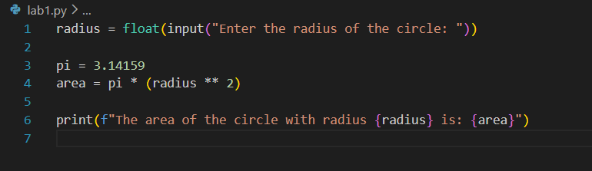
Output:
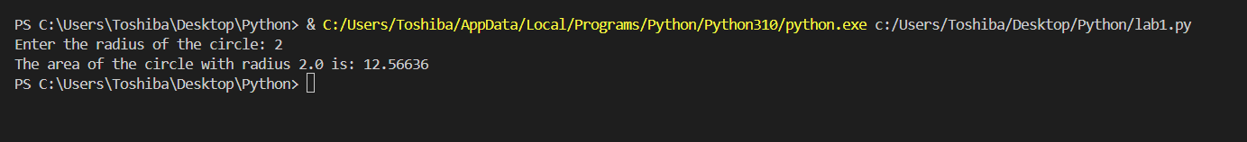
2. Write a program to swap two numbers.
Code:
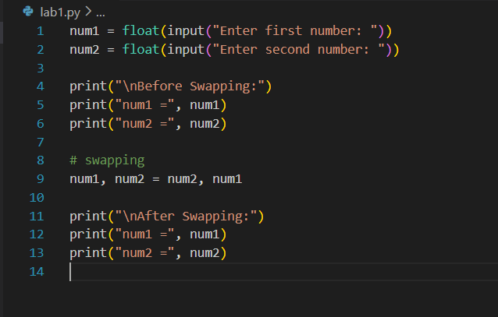
Output:
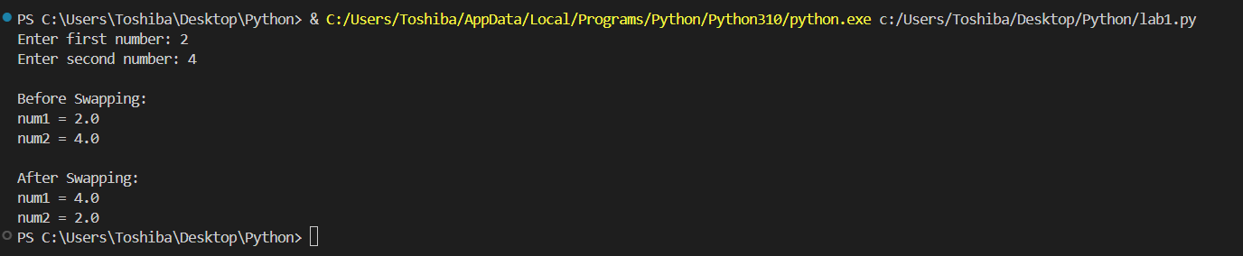
3. Write a program to convert Celsius into Fahrenheit. (C*9/5)+32.
Code:
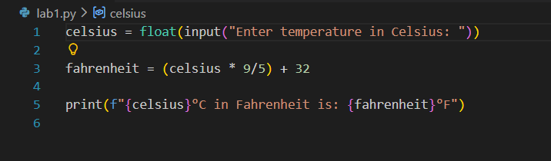
Output:
4. Write a program which Take marks of 5 subjects and calculate total marks and
percentage.
Code:
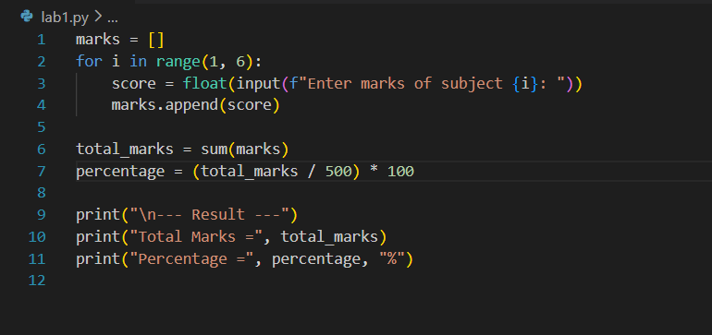
Output:
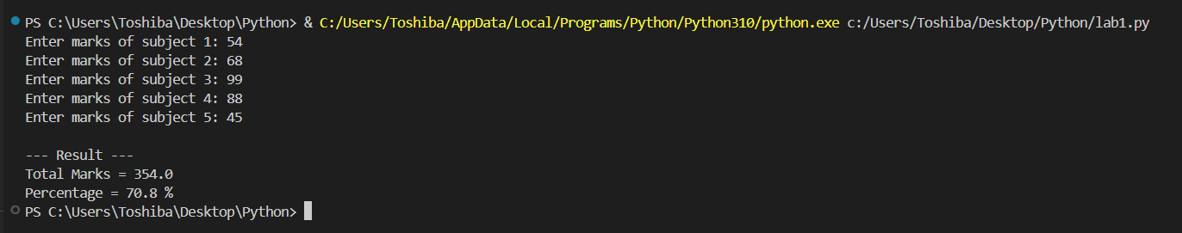
5. Write a program to convert an integer into a float and a float into an integer.
Code:
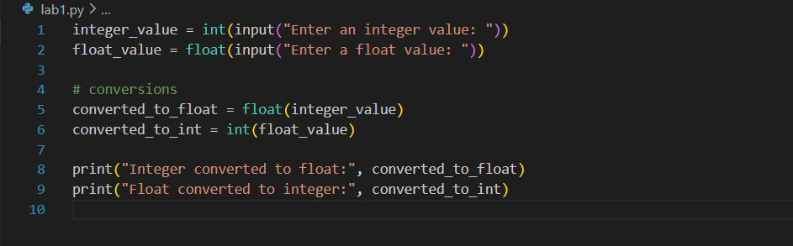
Output:
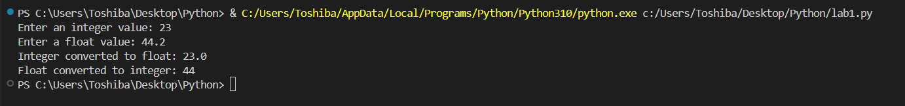
6. Create a list of five numbers and print the sum, max, and min values.
Code:
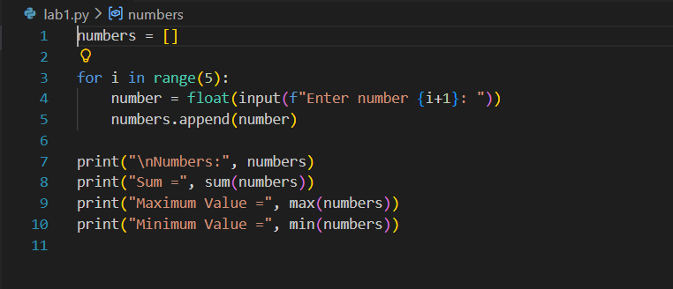
Output:
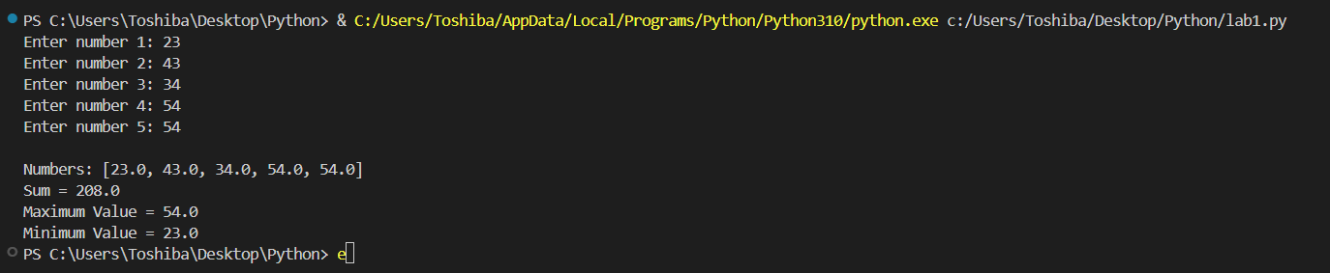
7. Write a program to take 5 names from the user and store them in a list.
Code:
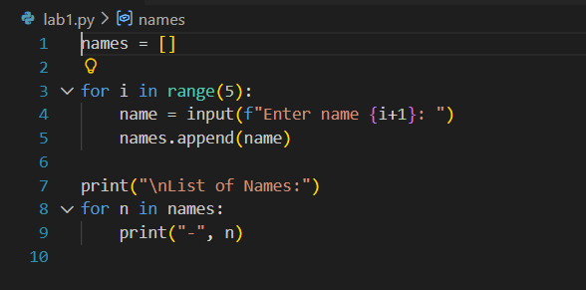
Output:
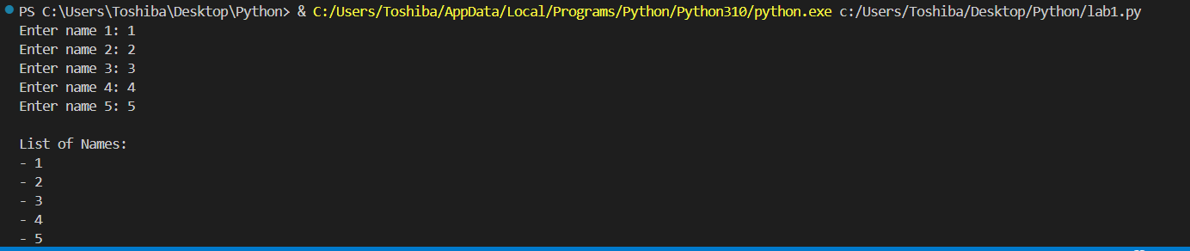
8. WAP which Add an element to the end of a list using append().
Code:
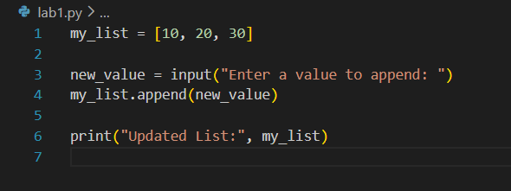
Output:
9. Insert an element at a specific index using insert().
Code:
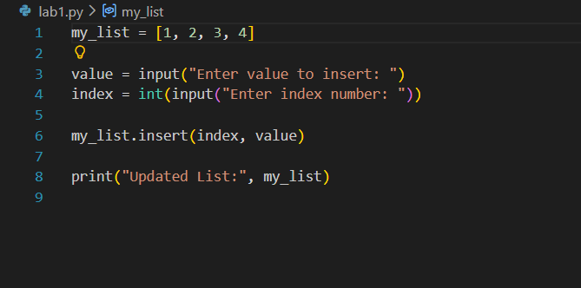
Output:
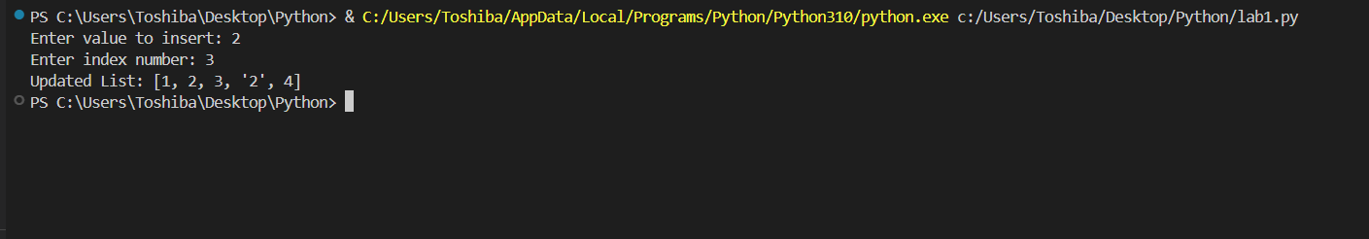
10. Remove an element from a list using both remove() and pop().
Code:
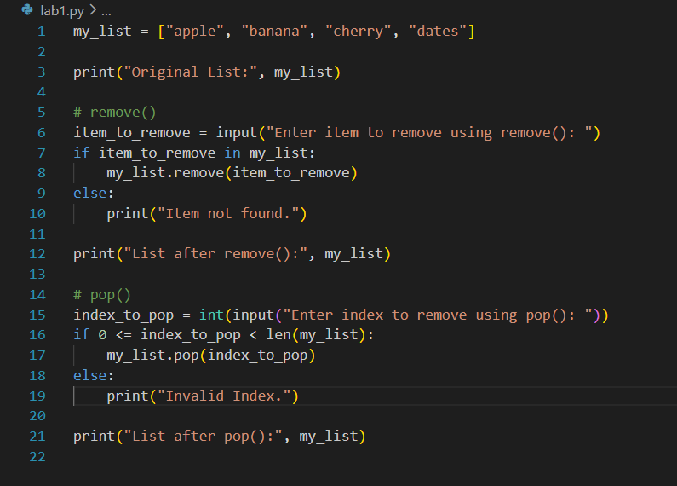
Output:
